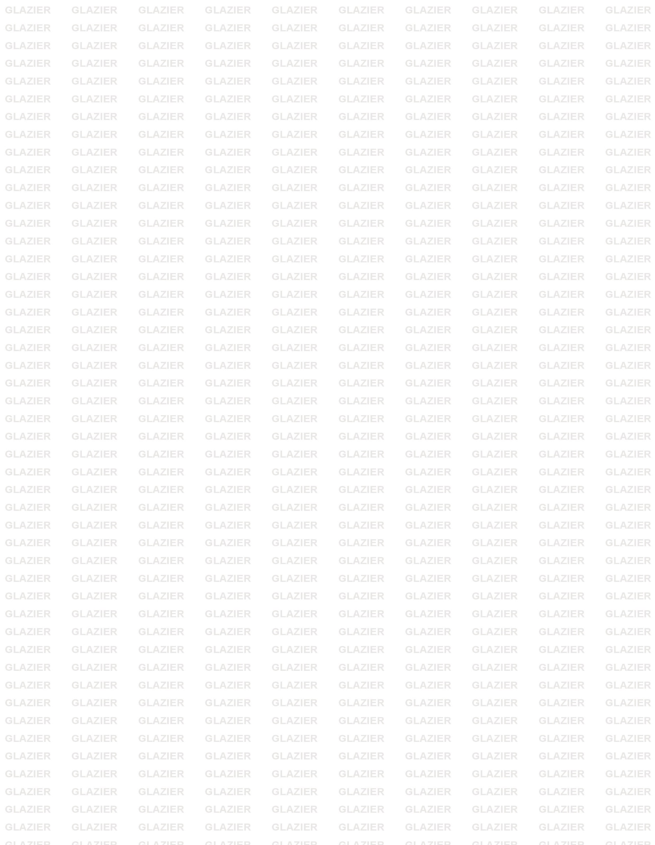

GLAZIER INTERNATIONAL FZC
PO Box 42326, Sharjah, Tel : +971504833176 / +971552313669, Email : info@glazierinternational.com
TRN No : 100339496000003

FERRO SILICON MANGANESE

Specifications | Mn | Si | C | P | S
FeSiMn 6014 | 60 % min | 14 % min | 2 % max | 0.30 % max | 0.05 % max
FeSiMn 6517 | 65 % min | 17 % min | 2 % max | 0.30 % max | 0.03 % max
FeSiMn 7018 | 75 % min | 1.50 % max | 2 % max | 0.30/0.50 % max | 0.03 % max
Size | 10-50 mm / 10-80 mm
Packing | Bulk or 1MT Big Bags

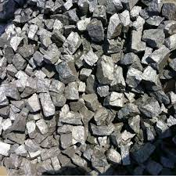

Packing : 1 ton Jumbo Bags unless otherwise specified.

Certificate of Conformity : Will be issued by Glazier if you need a third
party Analysis it will be issued at the buyer’s cost.

