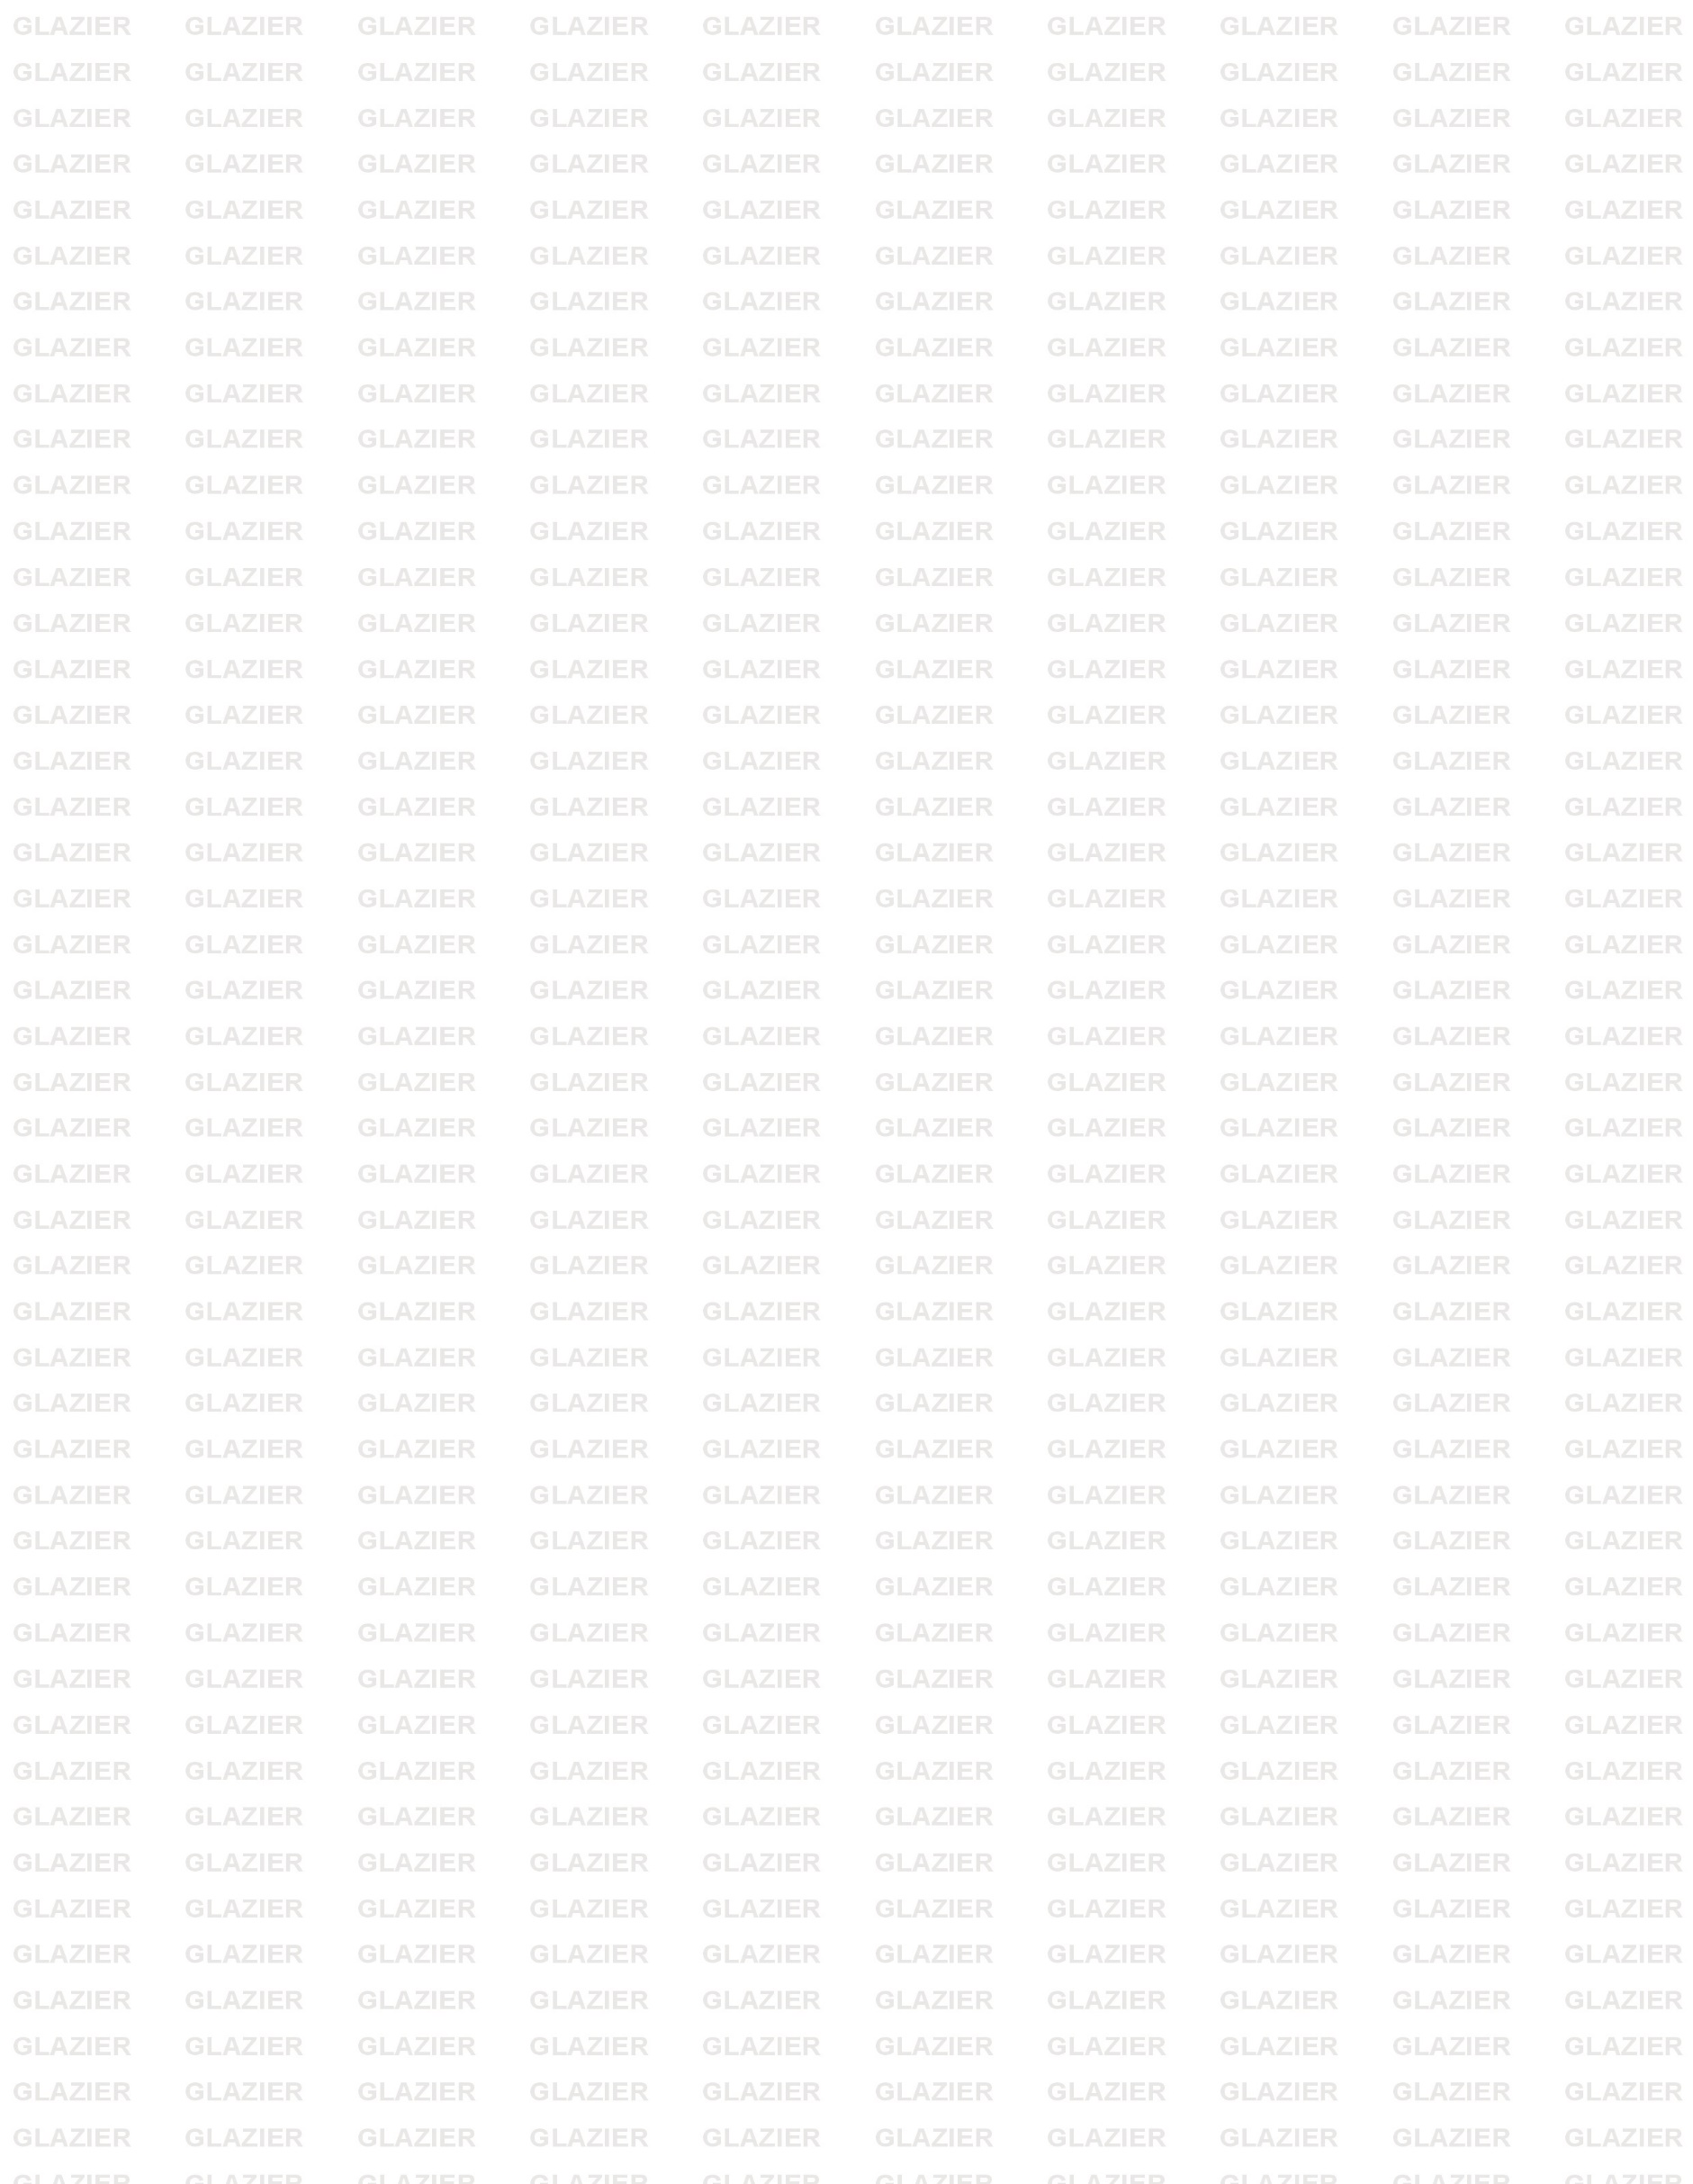

GLAZIER INTERNATIONAL FZC
PO Box 42326, Sharjah, Tel : +971504833176 / +971552313669, Email : info@glazierinternational.com
TRN No : 100339496000003

FERRO VANADIUM

Specifications
sV | 78 - 82 %
Al | 0.5 / 1.5 % max
Si | 1.5 % max
C | 0.1 / 0.25 % max
S | 0.05 % max
P | 0.05 % max
Cu | 0.10 % max
As | 1.05 % max
Size | 5-50 mm /10-50 mm / 10- 80mm
Packing | 1 MT Jumbo – Bags / Steel Drums

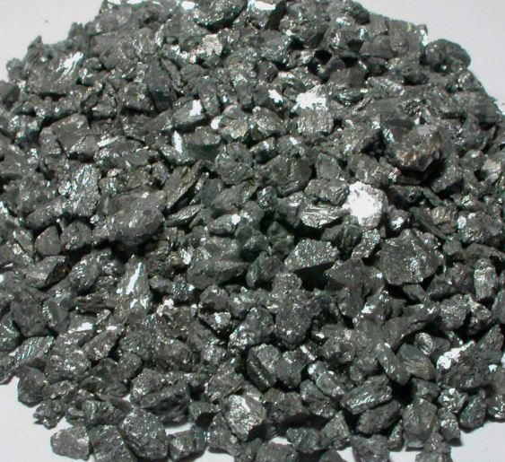

Packing : 1 ton Jumbo Bags unless otherwise specified.

Certificate of Conformity : Will be issued by Glazier if you need a third
party Analysis it will be issued at the buyer’s cost.

